Gotherator
Backend Software Specifications

0. Document Details

0.1 About This Document
This document represents software designs and specifications for the Gotherator backend API. It is meant to be technical and as complete/representative as possible.
0.2 Change log
note: Iteration matches the currently working release/tag
Iteration / Date | Section Changed / Added | Brief Description
V0.0.0 / 12/31/2017 | Initial Commit | Initial Commit

1. Architecture/Module Decomposition
The overall system uses a client-server architecture. These entities are completely separate and interact through well-defined interfaces. The architecture of the server shall be documented here.

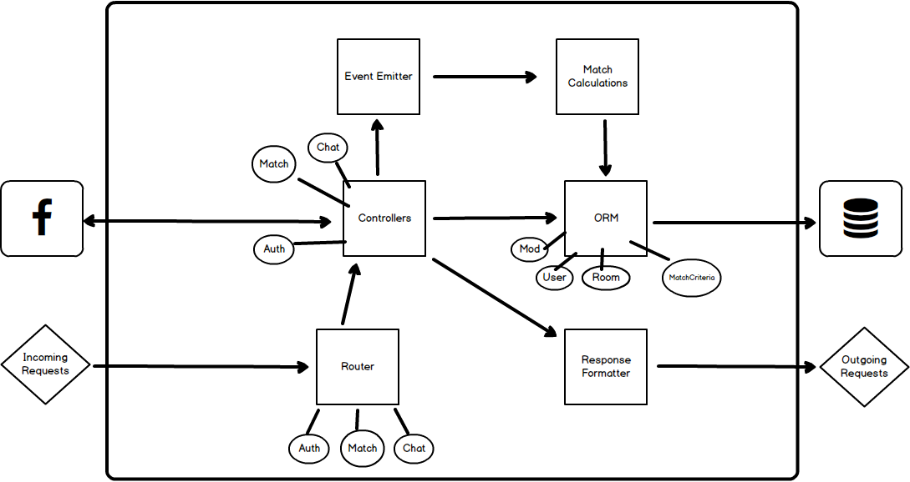

- Each Square represents an a Conceptual Module. Each Circle is a sub-class/module.

2. Models
Each model that will be persisted in the database.
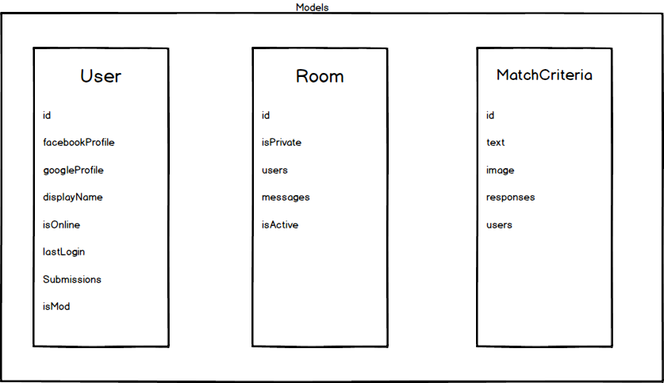

2.1 User Model API

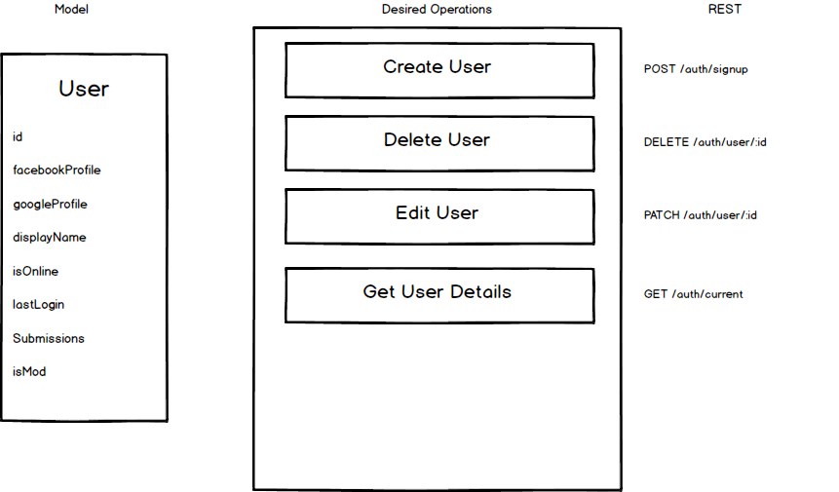

3. Module Designs

3.1 Router/Auth

